The app will start by providing a high level overview of the various components involved in delivering an application to your end users including load balancers, web servers and application servers. This app is targeting an IT Operations user that needs to see the health and well-being of these components and quickly correlate logs and metrics to triage application issues.

The inputs for this app are the same as the inputs required for ITSI's OOTB Modules & I'm including the models from ITSI as well. This provides an easy on ramp from the Insights app into ITSI. The TA's and add-on used in this app include the following:

|  |  |  |
| --- | --- | --- |
| Component | Name / Download Link | Notes / Installation Link |
| Operating System | [Splunk Add-on for Unix and Linux](https://splunkbase.splunk.com/app/833/) | enable bandwidth, cpu, df, vmstat, iostat, top, ps  (note: this requires the installation of sysstats - <http://sebastien.godard.pagesperso-orange.fr/download.html)> (<https://docs.splunk.com/Documentation/ITSI/2.6.1/IModules/OSModuleconfiguration> ) |
| Operating System | [Splunk Add-on for Microsoft Windows](https://splunkbase.splunk.com/app/742/) | enable WinHostMon for OS, processor & disk enable perfomon for cpu, system, logical disk, memory & network (<https://docs.splunk.com/Documentation/ITSI/2.6.1/IModules/OSModuleconfiguration> ) |
| Load Balancer | [Splunk Add-on for Citrix Netscaler](https://splunkbase.splunk.com/app/2770/) | <http://docs.splunk.com/Documentation/AddOns/released/CitrixNetScaler/Install> |
| Load Balancer | [Splunk Add-on for F5 Big-IP](https://splunkbase.splunk.com/app/2680/) | <http://docs.splunk.com/Documentation/AddOns/released/F5BIGIP/Setup> |
| Web Server | [Splunk Add-on for Apache Web Server](https://splunkbase.splunk.com/app/3186/) | Modify log file format on apache servers & add file inputs for log files  <http://docs.splunk.com/Documentation/AddOns/released/ApacheWebServer/Configure>  <http://docs.splunk.com/Documentation/AddOns/released/ApacheWebServer/Configureinputsv2monitor> |
| Web Server | [Splunk Add-on for Microsoft IIS](https://splunkbase.splunk.com/app/3185/) | Add file inputs for log files  <http://docs.splunk.com/Documentation/AddOns/released/MSIIS/Setupaddon> |
| Application Server | [Splunk Add-on for Java Management Extensions (JMX)](http://splunkbase.splunk.com/app/2647/) | 1. Set JAVA_HOME 2. Prep your JVM for the Add-On (<http://docs.splunk.com/Documentation/AddOns/released/JMX/SetupJMXservers> ) 3. Enable JMX & Configure Servers, Templates & Tasks thru Splunk Web (<http://docs.splunk.com/Documentation/AddOns/released/JMX/Configureinput> ) |
| Application Server | [Splunk Add-on for Tomcat](https://splunkbase.splunk.com/app/2911/) | 1. Configure JMX inputs (in the JMX Add-On in Splunk Web, Click Add Server…) <http://docs.splunk.com/Documentation/AddOns/released/Tomcat/Configureinputs> ) 2. Add a Server 3. Add a Task 4. Select a template 5. Setup the Add-on (execute lookups through Splunk Web) 6. Add file inputs for the log files (<http://docs.splunk.com/Documentation/AddOns/released/Tomcat/Setup> ) 7. Enable the Add-On (<http://docs.splunk.com/Documentation/AddOns/released/Tomcat/Configureinputs2> ) |
| Application Server | [Splunk Add-on for IBM WebSphere Application Server](https://splunkbase.splunk.com/app/2789/) | 1. Copy WebSphere jar files into the JMX TA's /bin/lib directory 2. Configure JMX inputs for WebSphere (<http://docs.splunk.com/Documentation/AddOns/released/IBMWAS/Configureinputs> ) 3. Add a Server 4. Add a Task 5. Select a template 6. Configure WAS File inputs (<http://docs.splunk.com/Documentation/AddOns/released/IBMWAS/Configureloginputs> ) 7. Enable the Add-On |
| Supporting Item | [Splunk Common Information Model](https://splunkbase.splunk.com/app/1621/) | Just install it |
| Supporting Item | [TA-user-Agents](https://splunkbase.splunk.com/app/1843/) | Just install it |
| Supporting Item | [Lookup File Editor](https://splunkbase.splunk.com/app/1724/) | Just install it |

Screenshots:

1. Overview

See the components of application delivery at a glance

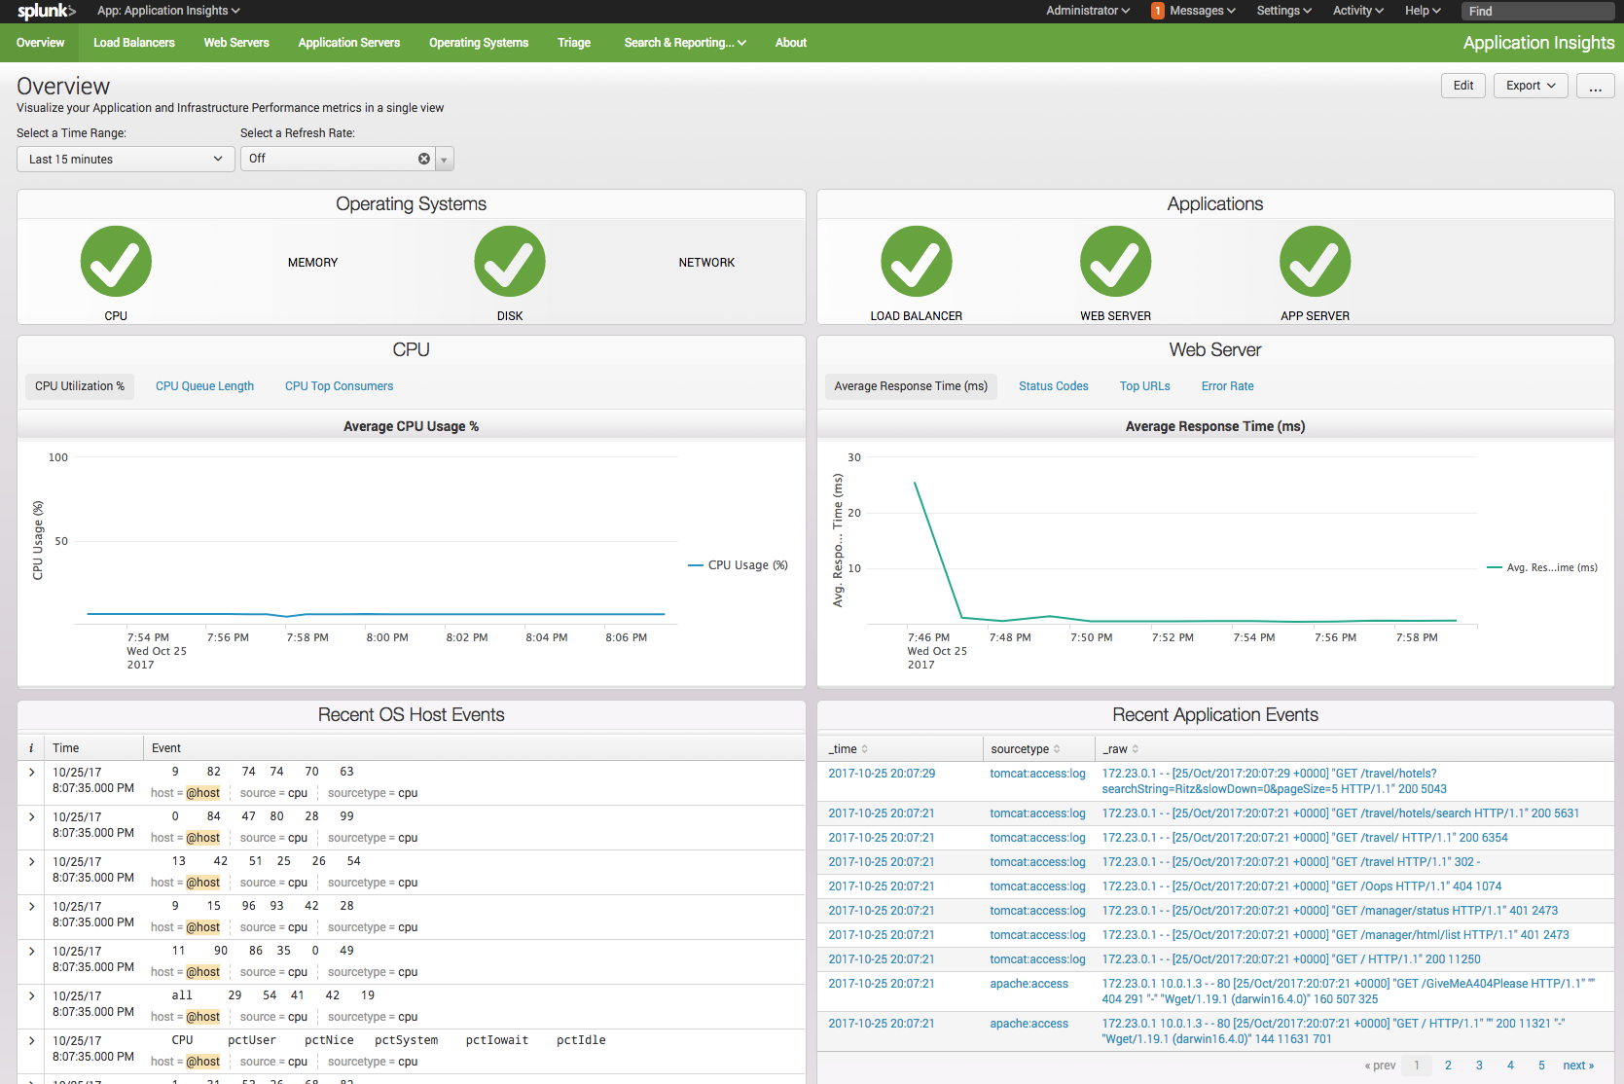

1. Triage

Identify patterns in the data and where you find high concentrations of similar error/fail/etc. messages, see what immediately preceded them.

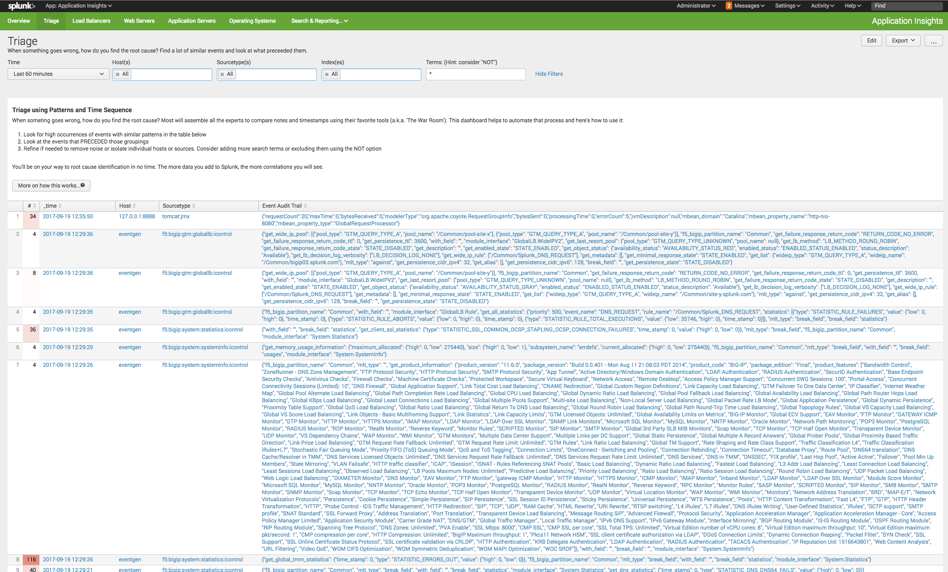

1. Load Balancers

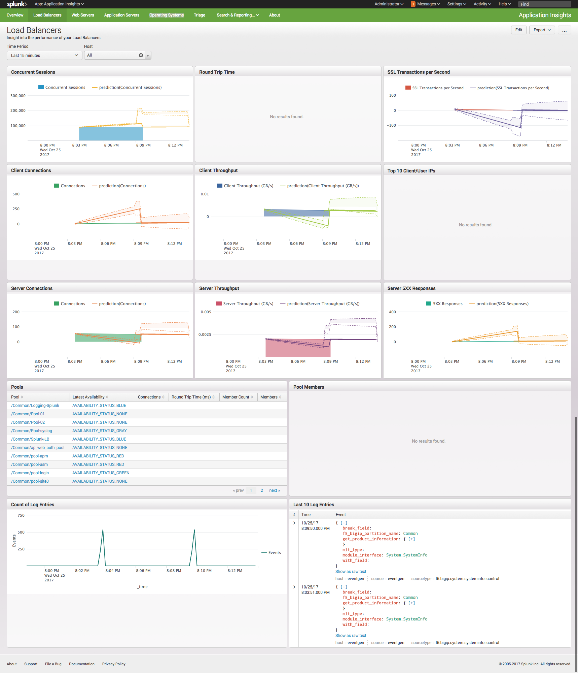

1. Web Servers

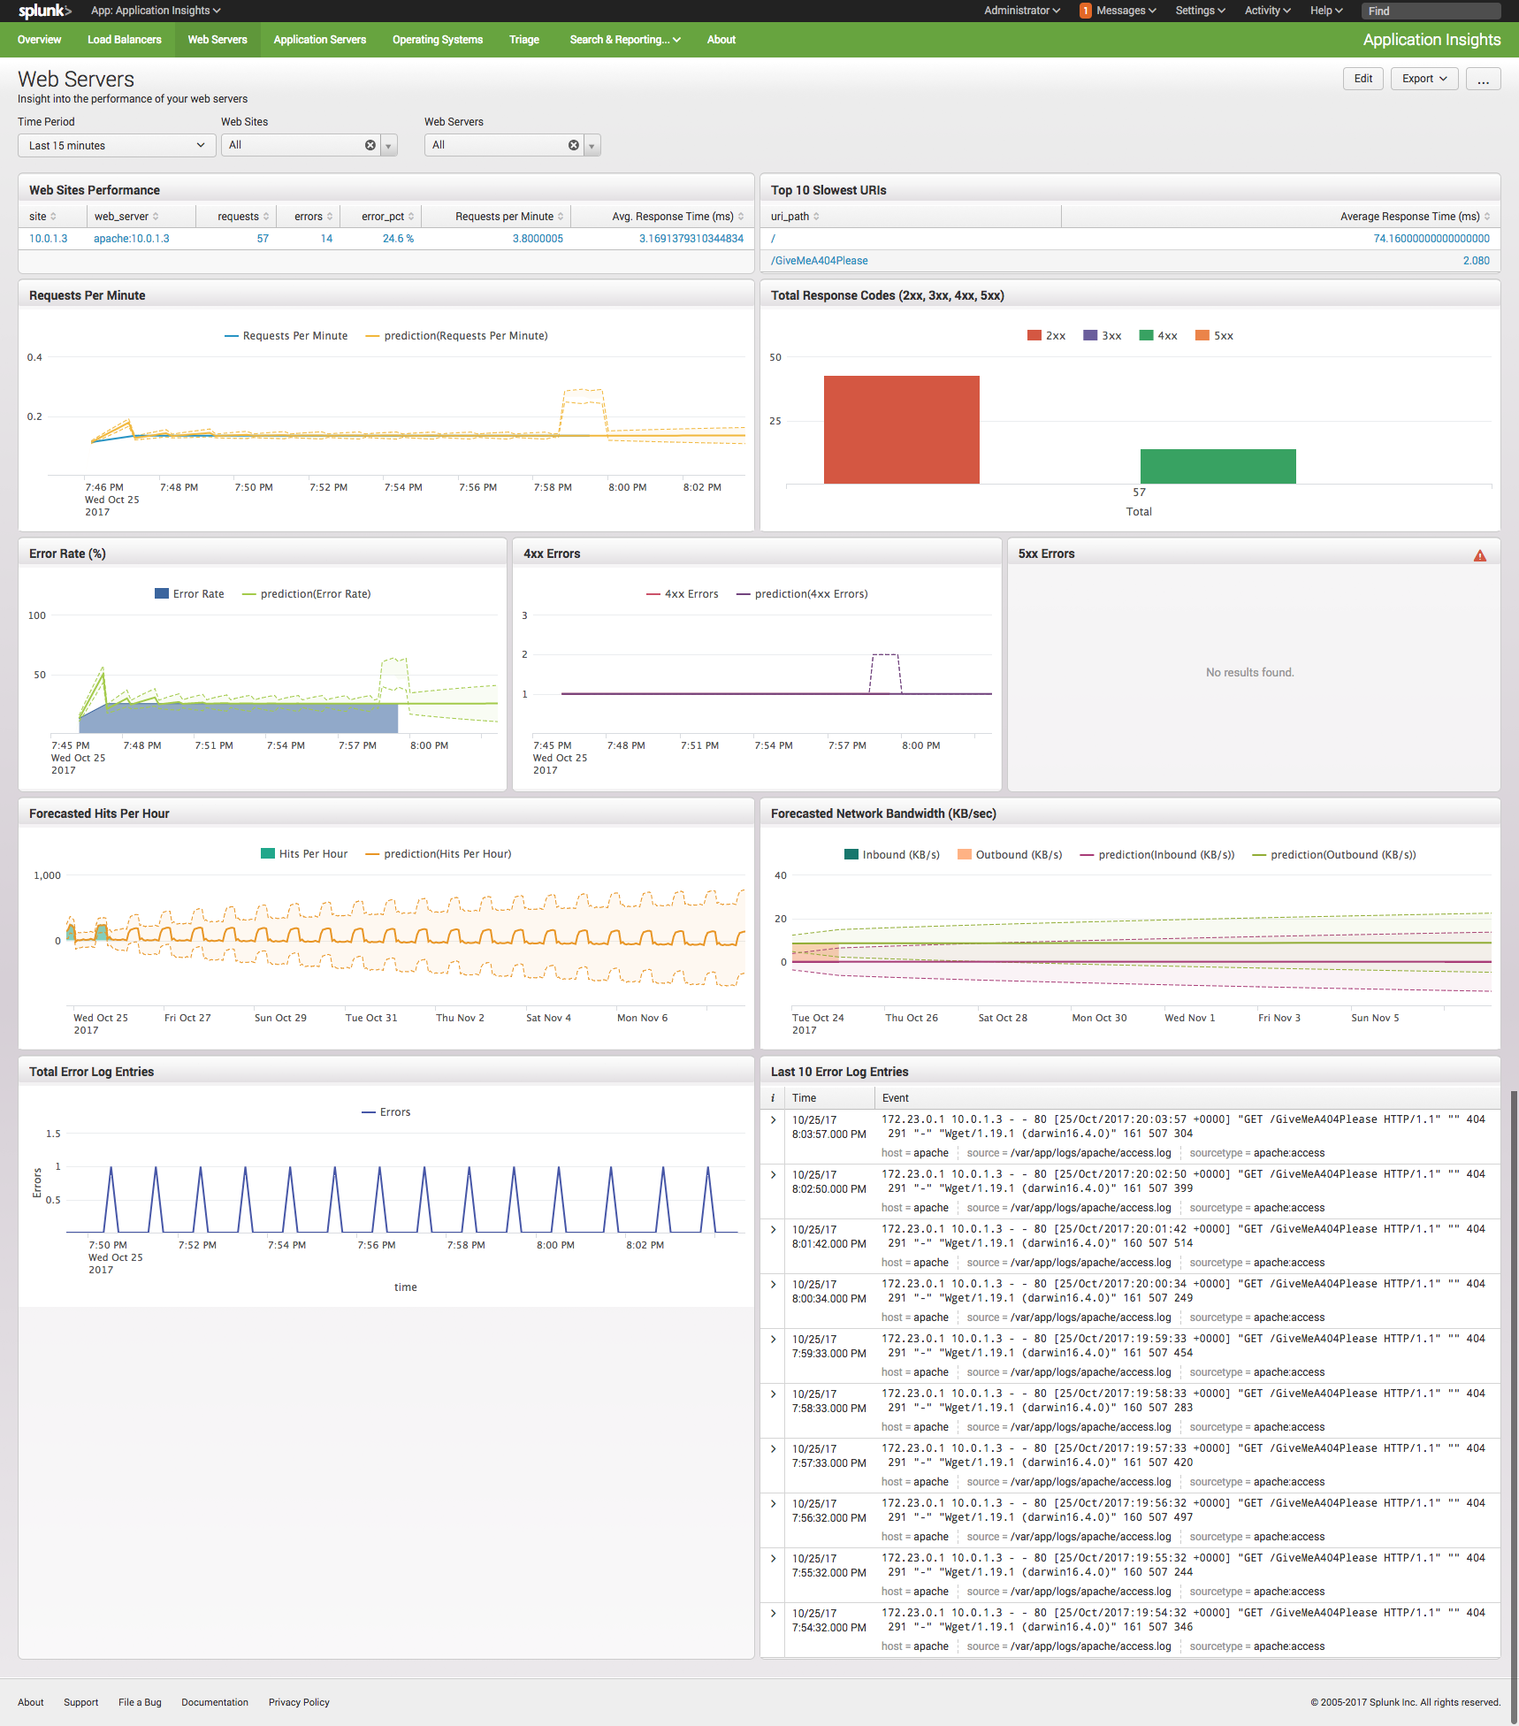

1. Application Servers

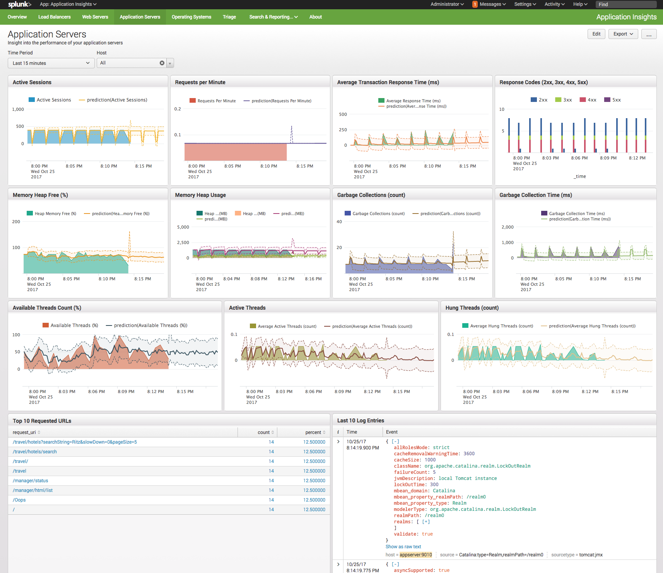

1. Operating Systems
2. 